There are many conclusions to be drawn regarding Kickstarter campaigns after reviewing 4113 campaigns.

There are 9 Main Categories and of those Theater, Music and Film & Video Campaigns have a higher success rate than the others. While Food and Technology campaigns have a higher rate of failed or cancelled campaigns.

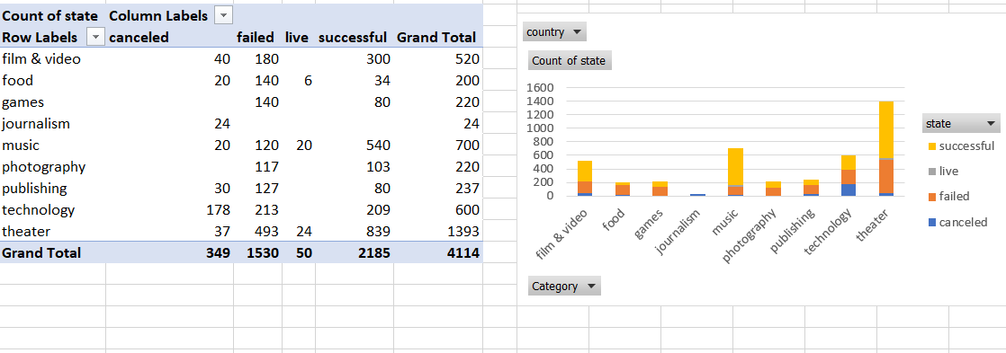

The Sub-Categories have very distinct conclusions.

The below subcategory campaigns were all Successful in reaching their goals:

* Documentary
* Electronic music
* Hardware
* Metal
* non-fiction
* Pop
* radio podcasts
* shorts
* tabletop games
* television

While the below Sub Categories All Failed or were Cancelled :

* Animation -Failed
* Children’s Books -Failed
* Drama -Failed
* Fiction -Failed
* Gadgets -Failed
* Jazz -Failed
* Nature -Failed
* People -Failed
* Places -Failed
* Restaurants -Failed
* Video Games -Failed
* Artbooks - Cancelled
* Audio - Cancelled
* Science Fiction - Cancelled
* World Music - Cancelled

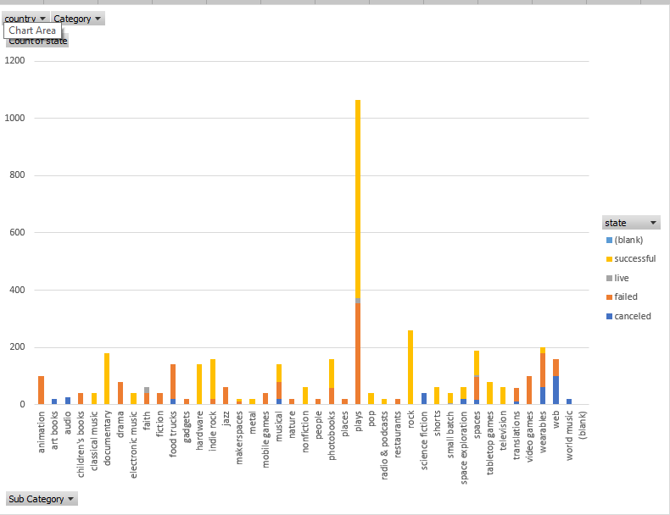

Out of the Nine Categories, Music (540), Film & Video (300) Theater (839) have the highest number of successful campaigns while journalism (0) and food (34) had the fewest successful campaigns.

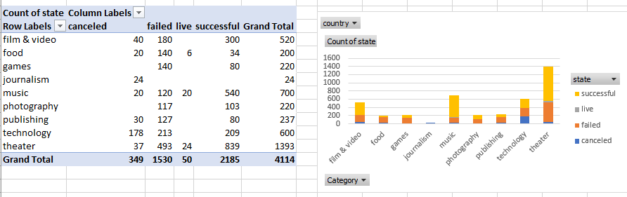

There are some limitations to Kickstarter Campaigns. The only information given about the campaign is the name and Blurb, therefore it is difficult to draw and conclusions about the how the implementation and marketing of the campaign affected the results of the campaign. There is also limited data given about the donors and pledges.

There are many more tables and graphs that could be created to learn more about Kickstarter campaigns based on the information provided.

* State percent by category and sub-category
* Time Frame for successful Campaigns.
* Meidan Donation per category and sub-category.
* State relationship to the goal amount.